**HORMISDALLEN SCHOOL - KYEBANDO**

**PRE- PLE SET 3 EXAMINATIONS, 2023**

**PRIMARY SEVEN SOCIAL STUDIES**

**Duration: 2 Hours 15 Minutes**

**NAME: ______________________________________________ STREAM: _________**

INDEX NO.

EMIS NO.

**SECTION A**

1. Mention any one way of finding directions of places.

____________________________________________________________________

2. Name the only fold mountain found in South Africa

____________________________________________________________________

3. State any one danger of building in a wetland.

____________________________________________________________________

4. In which units is altitude measured?

____________________________________________________________________

5. Name the major cash crop grown in Kilombero valley irrigation scheme.

____________________________________________________________________

6. In the space provided, draw a road sign for bridge.

7. Mention one way the government of Uganda spends revenue.

____________________________________________________________________

8. Mention any one country located in Northern Africa.

____________________________________________________________________

|  |  |  |
| --- | --- | --- |
| 9. | Write LEGCO | in full |

____________________________________________________________________

10. Name the main mineral mined in the Albertine region. ____________________________________________________________________

11. State one way of controlling soil erosion in hilly areas.

____________________________________________________________________

12. How does a country benefit from a large population?

____________________________________________________________________

13. Who was the political leader of MAU MAU rebellion?

____________________________________________________________________

14. What is meant by the term **population distribution?**

____________________________________________________________________

15. Mention any one symbol of Uganda as a nation.

____________________________________________________________________

16. State the main reason why the Uganda railway was extended to

Kasese.

____________________________________________________________________

17. Give one importance of wild animals to the government.

____________________________________________________________________

18. Name the explorer who helped to stop slave trade in Northern

Uganda.

____________________________________________________________________

19. Mention one weather instrument which is kept in a Stevenson

Screen.

____________________________________________________________________

20. Into which water mass does the Nile flow?

____________________________________________________________________

21. How does a school fence promote school security?

____________________________________________________________________

22. Why did traders in Trans Saharan Trade move in caravans?

____________________________________________________________________

23. Which ministry prepares the national budget in Uganda?

____________________________________________________________________

24. Mention one way of becoming a citizen of Uganda.

____________________________________________________________________

25. Give one way colonialists established their rule in Africa.

____________________________________________________________________

26. Mention one way of controlling desertification.

____________________________________________________________________

27. Name the seaport which handles most goods of Uganda.

____________________________________________________________________

28. How are farmers important to agro based industries?

____________________________________________________________________

29. Write any one member of a nuclear family.

____________________________________________________________________

30. How is a trash bin important in a classroom?

___________________________________________________________________

31. How is the structure below important in a homestead?

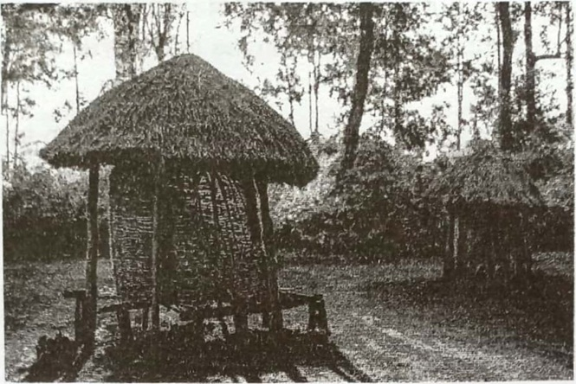

____________________________________________________________________

32. State one way Apartheid was practiced in South Africa.

____________________________________________________________________

33. Mention the group of people who benefit from UNICEF.

____________________________________________________________________

34. Under which ethnic group are the Ngoni of Tanzania?

____________________________________________________________________

35. State one importance of trees in a school compound.

____________________________________________________________________

For each of the questions **36 to 39**, answer EITHER the Christian OR the Islamic questions but not both. NO marks will be awarded to a candidate who attempts both alternatives in a particular number.

**36. EITHER**

According to Christianity, who was sent on earth to save mankind?

____________________________________________________________________

|  |  |  |  |  |  |
| --- | --- | --- | --- | --- | --- |
| OR |  |  |  |  |  |
| According | to Islam, whom | did Allah | send | to | perfect Islam? |

___________________________________________________________________

**37. Either:** How is a Bible important to Christians?

____________________________________________________________________

**OR:** How is a Quran important to Muslims?

___________________________________________________________________

38**. EITHER**

Which group of foreigners introduced Christianity in Uganda?

____________________________________________________________________

**OR:** Which group of foreigners introduced Islam in Uganda?

___________________________________________________________________

**39. Either:** Give one way Christians reconcile with God.

____________________________________________________________________

**OR:** Give one way Muslims reconcile with Allah.

___________________________________________________________________

40. **FOR BOTH**

State one example of a good decision

____________________________________________________________________

**SECTION B(6oMARKS)**

41 . (a) Write EAC in full.

___________________________________________________________________

(b) Name the town where the headquarters of EAC are located.

___________________________________________________________________

( c) State one benefit of the EAC to member states

___________________________________________________________________

42. (a) Which organization sent most explorers to East Africa? ___________________________________________________________________

(b) Mention any two problems explorers faced in East Africa.

i) _________________________________________________________________

ii)________________________________________________________________

43. (a) Why was early man called Stone Age man?

___________________________________________________________________

(b) Give any one reason why early man tamed a dog.

___________________________________________________________________

c) Mention any two ways fire was important to early man.

i)__________________________________________________________________

ii)__________________________________________________________________

44. (a) Mention any two examples of tourist attractions in Uganda.

___________________________________________________________________

(b) Give any one importance of tourism to the government of Uganda.

___________________________________________________________________

( c) State any one problem facing the tourism industry of Uganda.

___________________________________________________________________

45. Study the sketch map of East Africa and use it to answer the questions that follow

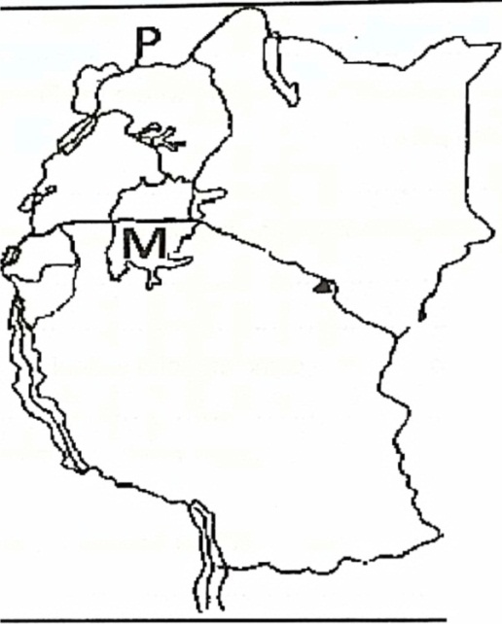

|  |  |
| --- | --- |
| (a) (b) | Use letter T to locate Mount Kilimanjaro on the above map. Name the country marked with letter P |

|  |  |
| --- | --- |
| (c) | Mention one African country located in the ocean labeled A |

___________________________________________________________________

|  |  |
| --- | --- |
| (d) | Give one economic importance of Lake M to East Africa. |

46.a) Name any one tax that was introduced by the 1900 Buganda agreement.

___________________________________________________________________

b) State any two effects of the 1900 Buganda agreement.

i)__________________________________________________________________

ii)__________________________________________________________________

c) Why did the British colonialists introduce taxes in Uganda?

__________________________________________________________________

47. (a) What was 'assimilation policy' as it was used by France in

French West African Federation?

___________________________________________________________________

(b) Name any one African country where the French applied assimilation policy ___________________________________________________________________

(c) Mention any two ways colonialists brought development in Africa.

i)_________________________________________________________________

ii)_________________________________________________________________

48. (a) Mention one source of income of a school

___________________________________________________________________

(b) Which type of budget enables a school to save money?

_________________________________________________________________

(c) Mention any two ways a school spends its income.

i)_________________________________________________________________

ii)_________________________________________________________________

49.(a) What is meant by the term land fragmentation?

___________________________________________________________________

(b) Give any two ways land is important to people.

i)__________________________________________________________________

ii)__________________________________________________________________

(c) State one way people misuse land.

___________________________________________________________________

50. a) Give any two reasons why the African Union was formed.

i)__________________________________________________________________

ii)__________________________________________________________________

b) What role does ECOMOG play in relation to ECOWAS?

___________________________________________________________________

c) How has African Union tried to restore peace in Somalia?

___________________________________________________________________

**For each of the questions 51 to 54, answer EITHER the Christian OR the Islamic questions but not both. NO mark will be awarded to a candidate who attempts both alternatives in a particular number.**

**51 Either:** a) What are voluntary organisations?

___________________________________________________________________

b) Mention any two ways voluntary organisations help the needy people

i)__________________________________________________________________

ii)__________________________________________________________________

(c )Name any one example of a voluntary organization which operates in Uganda.

__________________________________________________________________

**OR:** a) What are voluntary organisations?

___________________________________________________________________

b) Mention any two ways voluntary organisations help the needy people i)__________________________________________________________________

ii)__________________________________________________________________

c) Name any one example of a voluntary organization which operates in Uganda.

__________________________________________________________________

52. EITHER

(a) Name the day when the apostles received the Holy Spirit.

__________________________________________________________________

b) Give one form in which the Holy Spirit appeared to apostles.

_________________________________________________________________

(c) Mention two ways the Holy Spirit is important to Christians.

i)__________________________________________________________________

ii)__________________________________________________________________

**OR:** (a) Define the term Miraj.

_________________________________________________________________

(b) From which town did Prophet Muhammad perform Miraj?

_________________________________________________________________

(c) Mention any two prophets which were met by Prophet

Muhammad during Miraj

i)__________________________________________________________________

ii)__________________________________________________________________

**53. Either:** a) (a) What is success?

__________________________________________________________________

b) Mention any two factors which lead Christians to success

i)__________________________________________________________________

ii)__________________________________________________________________

c) State one factor which causes failure among Christians.

__________________________________________________________________

**OR:** a) What is success?

__________________________________________________________________

b) Mention any two factors which lead Muslims to success.

i)__________________________________________________________________

ii)__________________________________________________________________

c) State one factor which causes failure among Muslims.

__________________________________________________________________

**54. Either:** a) What is marriage?

___________________________________________________________________

b) Mention any two qualities of a good marriage partner.

i)__________________________________________________________________

ii)__________________________________________________________________

c) State any one reason why Muslims marry.

___________________________________________________________________

**OR:** a) What is marriage?

___________________________________________________________________

b) Mention any two qualities of a good marriage partner.

i)__________________________________________________________________

ii)__________________________________________________________________

c) State any one reason why Muslims marry.

___________________________________________________________________

**FOR BOTH**

55. (a) What is sin?

___________________________________________________________________

(b) Mention any one cause of sin today.

__________________________________________________________________

c) State any two consequences of sin

i)__________________________________________________________________

ii)__________________________________________________________________

**END**